**PROJECT-2**

**SMART HOME ENERGY MONITORING SYSTEM**

**#Simulates IOT-based household energy monitoring**

**Inputs:device usage data,IOTsensors**

**Outputs:real-time graphs,peak demand detection**

**SOURCE CODE:**

**import pandas as pd**

**data={**

**'Devices':['device1','device2','device3'],**

**'Usage':[3,4,2],**

**'Iot_sensors':[2,3,4]**

**}**

**df=pd.DataFrame(data)**

**df['Total usage'] = df['Usage'] + df['Iot_sensors']**

**print(df)**

**import matplotlib.pyplot as plt**

**real_time=[2,3,6]**

**total_usage=[5,6,7]**

**maximum_demand=[6,7,8]**

**plt.plot(real_time,total_usage,marker='o')**

**plt.xlabel('real time(s)')**

**plt.ylabel('total usage')**

**plt.title("real time vs total usage curve")**

**plt.show()**

**plt.plot(real_time,maximum_demand,marker='o')**

**plt.xlabel('real time(s)')**

**plt.ylabel('maximum demand')**

**plt.title("real time vs maximum demand curve")**

**plt.show()**

**OUTPUT:**

**Devices Usage Iot_sensors Total usage**

**0 device1 3 2 5**

**1 device2 4 3 7**

**2 device3 2 4 6**

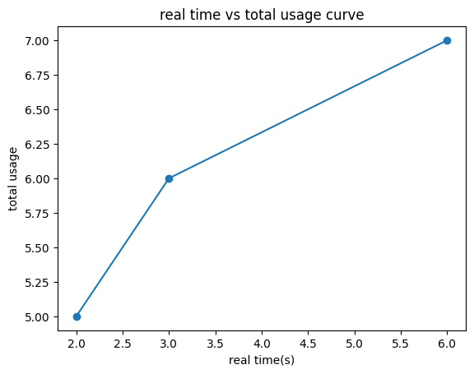

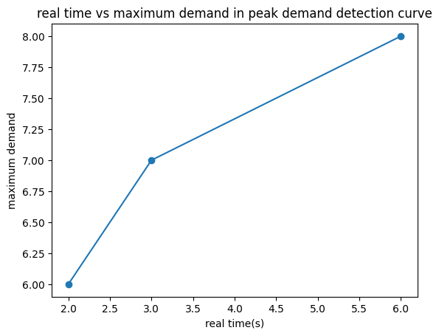

**CONCLUSION:**

**The IoT-based household energy monitoring system effectively analyzes device usage data through IoT sensors to provide real-time graphical insights into energy consumption patterns. It enables peak demand detection, allowing users to optimize electricity usage, reduce wastage, and improve overall energy efficiency in smart homes.**